# First Screenshot:

Screenshot of the main menu and the option to list the files in the directory:

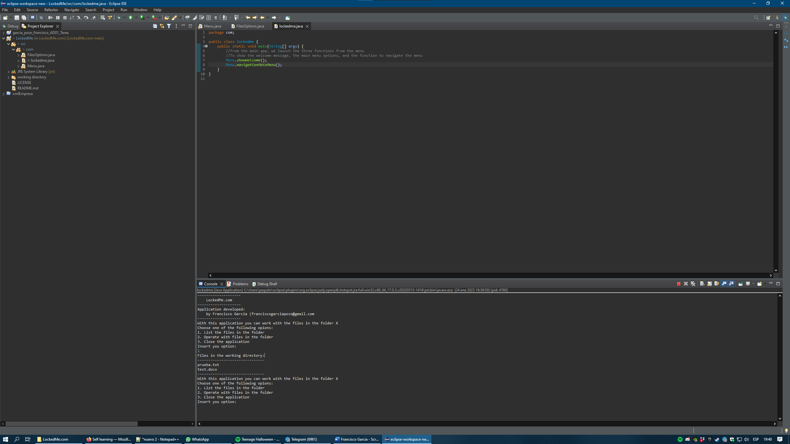

# Second Screenshot:

Screenshot of list the files in the directory (with the directory empty):

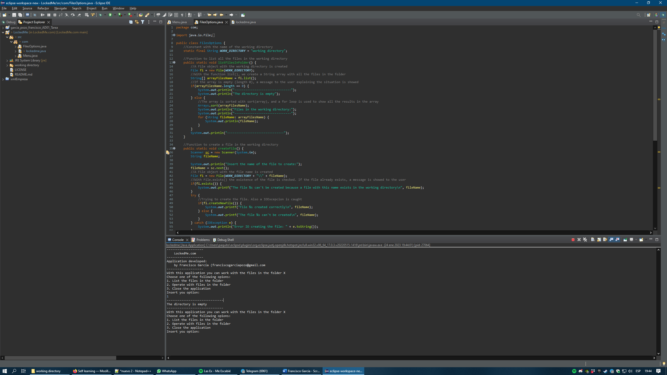

# Third Screenshot:

Screenshot of the sub menu and the option to create a file in the directory:

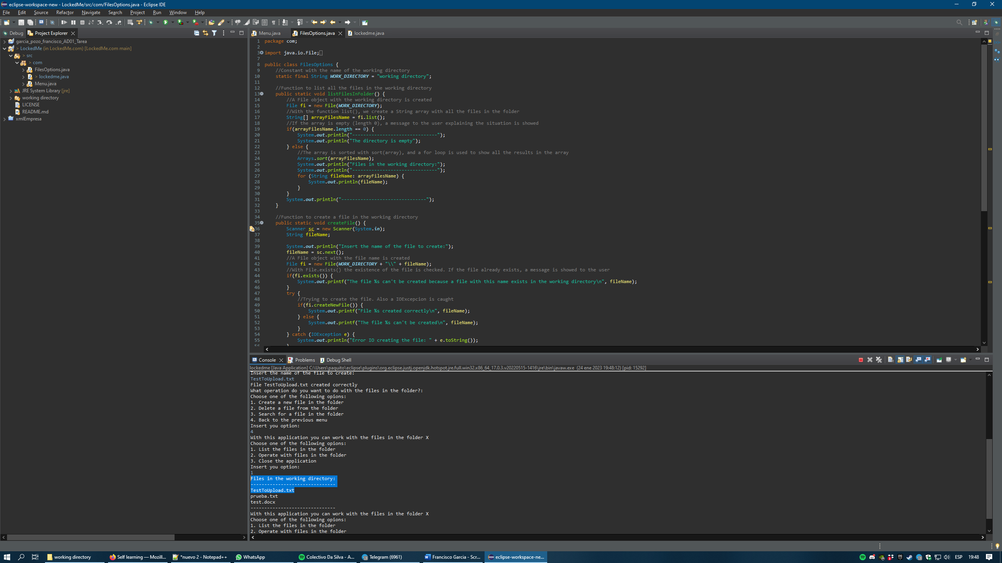

# Fourth Screenshot:

Screenshot of the search for a file option:

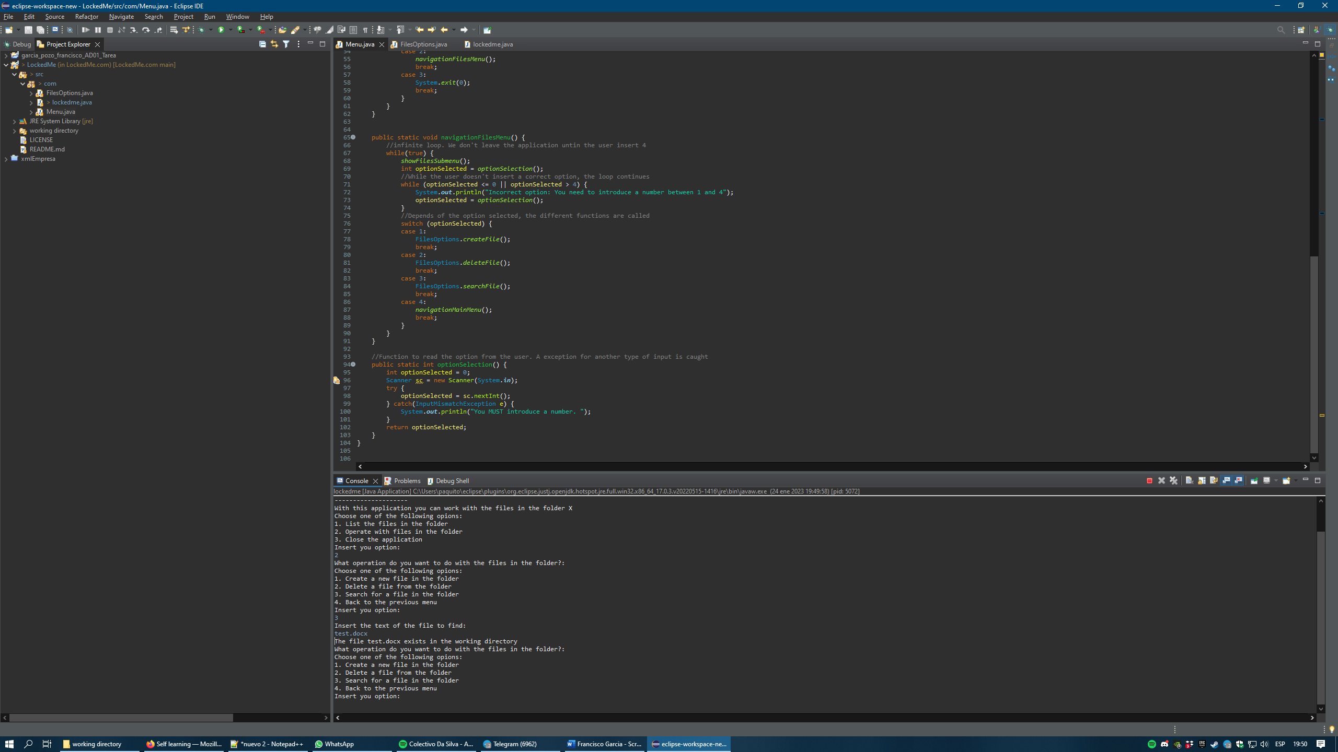

# Fifth Screenshot:

Screenshot of the delete a file option:

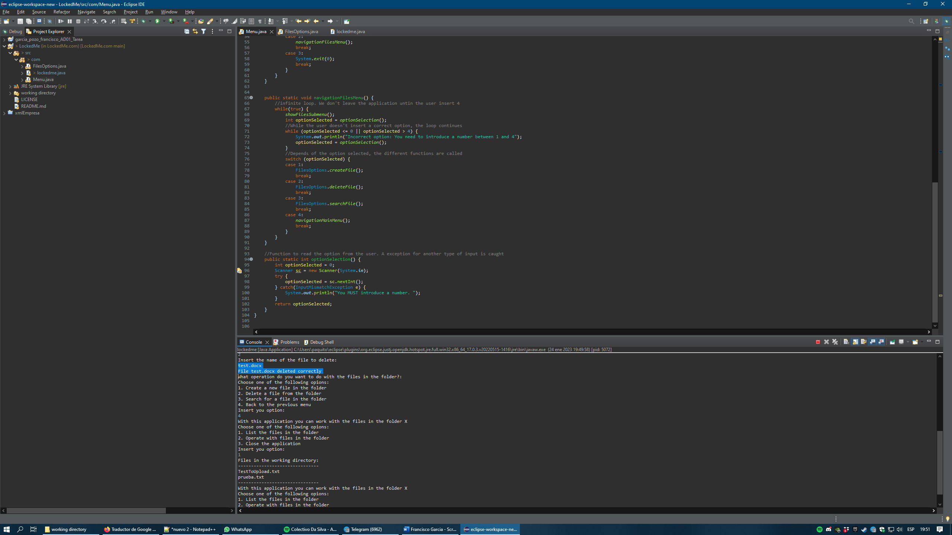

More info about the project can be found in the GitHub project:

<https://github.com/FranciscoGP-telco/LockedMe.com>